**LAB Book partners up with Practical Tableau Book: Used for Tableau Desktop Level 2**

**This Lab book is Part 1 of 5 Parts. Part 1 has been designed for anyone who wants to prepare for Parts 2-5. If you did not take the Tableau Desktop Level 1 class, you should work your way through this Part 1 Lab Book, to be sure you understand the concepts taught in that class.**

**Desktop Level 1 Skillset is expected for success in this Desktop Level 2 Class**

**\*\*\*Please note, all exercises will be created from scratch. However, the SOLUTION files for this Lab Book are located in the Workbooks folder and named “PartOne.twbx”.**

Part 1 –

Chapter 8 - Exercise (Bar Chart Options) - 10 Minutes – Book Pages: 35-37 (top)

1. **Use Excel Sample Superstore, ORDERS table:**

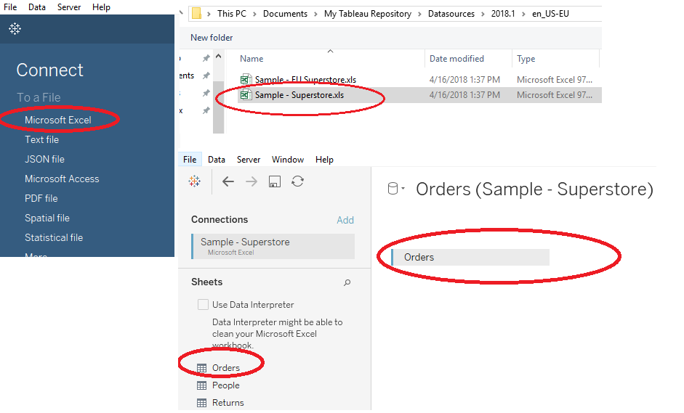

1. **Rename Sheet 1 to Bar Chart Options (which will also change the title of the page to “Bar Chart Options” – Additionally: right click the sheet tab and choose “color” off the menu. (*note: these colors are your preference, but back at work, you may consider using them to differentiate departments, or sheets vs. dashboards, or projects, etc.)**

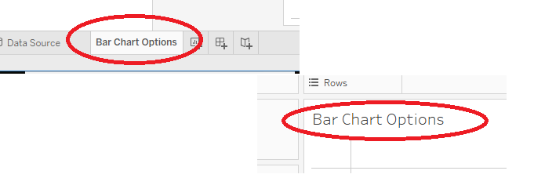

1. **SAVE Entire Workbook to your desktop. Name the File: “PartOne.twbx”– you will use this workbook throughout Part One of Practical Tableau Book.**
2. **Once you have the steps above opened, you will try each of the FIVE bar chart options discussed in your book on pages 35 and 36. Please follow the steps below to complete these five options:**

**Option 1** – Double Click the SALES Measure. Result: plain blue bar chart – click the undo button

****

**Option 2** – Left Drag your SALES Measure to the row –Result: same blue bar chart as above – click the undo button

****

**Option 3 –** Click ONCE on the SALES Measure, Go to the SHOW ME Box and select the bar chart (3rd row, 1st column) – Notice the bar chart by default is horizontal. Also Note that the Show Me Wizard changed the position of your SALES Field. It is now located in the Column Shelf.

Find the “SWAP” tool on the toolbar (or press CTRL + W)

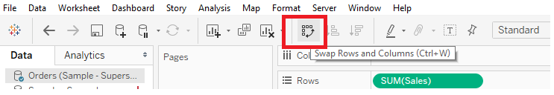

Additionally: Click the swap tool again to watch it toggle back and forth between horizontal and vertical. (Notice your SALES measure moving back and forth between Column and Row Shelves.

CLEAR THE WORKSHEET: (Find “CLEAR” tool and click or press ALT_SHIFT_BACKSPACE)

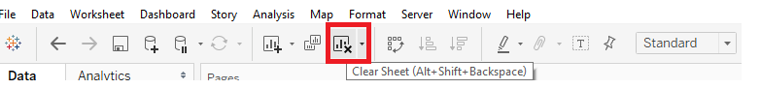

****

**Option 4 –** Change to a bar chart using the MARKS SHELF:

Drag ORDER Date Dimension to the Column Shelf, Drag SALES Measure to Rows Shelf (see picture on Page 36 of your book).

Go to the MARKS Shelf and Choose BAR CHART from the options:

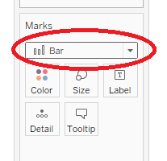(Notice that when you use the MARKS shelf, as opposed to the “SHOW ME” Wizard, your SALES and ORDER DATE field remain in place. As you learn more about Tableau, you will rely less and less on the Wizard and learn to use the MARKS Shelf to create your charts)

CLEAR the Worksheet

***

**Option 5** – RIGHT Click and Drag the SALES Measure to the ROWS Shelf. (Result: See picture on Page 37 of your book.) – This result gives an option to choose an aggregate. Choose MEDIAN(SALES), Choice # 2 from List. A right click in Tableau can offer quicker options than going through many menus to get the desired result.

**SAVE THE WORKBOOK and keep this worksheet open for next exercise.**

Part 1 - Chapter 8 - Exercise (Bar Chart Analytics) - 5 Minutes (Book Page: 37)

Continuing with MEDIAN(SALES) on ROW SHELF , drag REGION to the COLUMNS SHELF AND a second REGION pill to the COLOR Card On the MARKS Shelf).

Next, Click on the Analytics TAB

Under “Custom”, Choose “Reference Line” – then drag and drop on top of TABLE

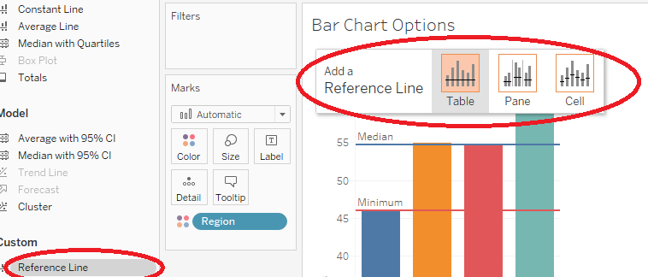

You will see the screen below. Pick “Median” from the computation dropdown AND choose a line color from the Line Dropdown:

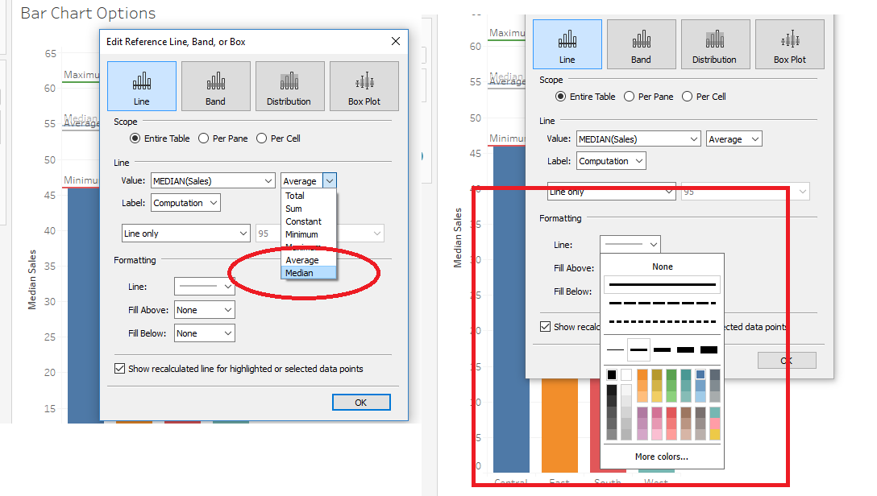

Repeat these actions twice more, once to depict MINIMUM and once to depict MAXIMUM:

Your final result should look like this:

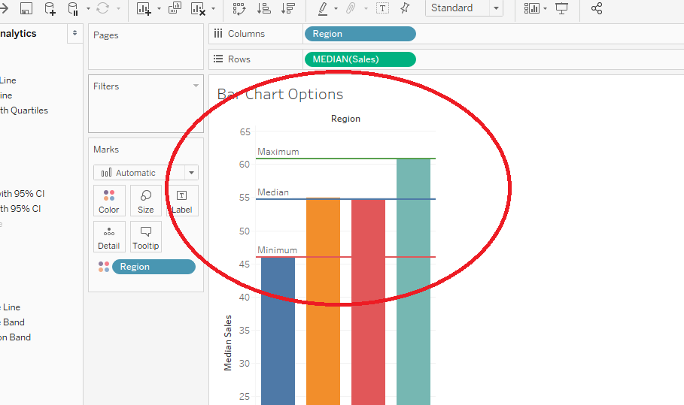

SAVE YOUR WORKBOOK

Chapter 9 - Exercise (Line Graphs/Axes/Dates) - 10 Minutes- (Book Pages 41-46)

1. Add a new sheet to your workbook. Name the Sheet “Line Graphs” and additionally, change the color if desired.
2. Double click Sales Measure (to bring it to ROW SHELF)
3. RIGHT CLICK and DRAG the Order Date Field into the COLUMN SHELF. From the pop up menu, choose the GREEN (Continuous) - MONTH(Order Date) (4th from bottom), off the list.
4. Click on the COLOR CARD in the MARKS SHELF and choose the middle marker toward the bottom.
   * Notice that the SORT tools are not available for the Order Date Field. Continuous fields cannot be sorted.
   * Notice that Tableau associates time with Line Charts by default.
   * See picture on page 41 of your book to confirm result.
5. Drag the “Ship Mode” dimension to the Row.
   * Notice that the pill only goes in FRONT of the Sales Measure. You cannot move it afterward. This is because it is a SLICER and the SLICE happens before the SALES Measure.
   * Notice that each Axis has the same range. If we want to reflect accurately, we need to change this.
6. Right click any SALES axis field (left side of view), and choose “Edit Axis”. Under Range, choose “Independent Axis Ranges for each row or Column”
   * Check result with page 44 picture in your book.
7. Go to the GREEN – ORDER DATE pill and click the plus sign twice to see how the DATE HEIRACHY works. Also, you can DRILL UP by clicking the undo tool, to go backwards.
8. Next, remove the GREEN ORDER DATE PILL from the COLUMN Shelf (RIGHT CLICK a white part of the column shelf and choose “CLEAR SHELF”.
9. LEFT DRAG the ORDER DATE field to the COLUMN SHELF. Leave it blue (discrete). Notice it CAN be sorted. We did not filter this for months, so note the plus sign starts on the YEAR option. . You can click the hierarchy plus signs all the way through to the DAY. Then, you can click the plus signs and drill back down. The main difference is that you can SORT Discreet fields.

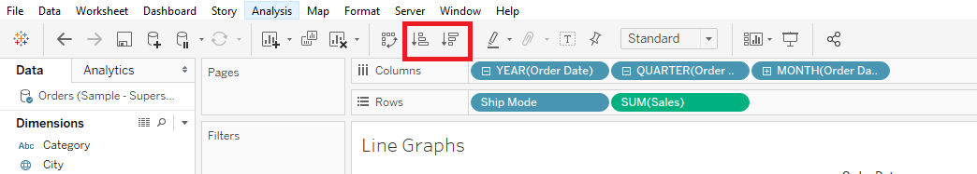

1. Additionally, feel free to use plus signs and sort tools to practice with DATES and HEIRARCHIES.
2. Save the workbook.

Chapter 10 - Exercise (Level of Detail and Scatters) - 5 Minutes – Book Pages: 49-50

1. Get a new worksheet, name it “Level of Detail” and color the tab if desired.
2. Create a new calculated field called “Profit Ratio”.
3. Start this calculation by clicking on the “Analysis” menu and then “Create Calculated Field” – or, you could RIGHT click on a white area in the Meaures area and “Create Calculated Field” 0r you could right mouse click an existing measure and create a calculated field.
4. Then type in : Sum([Profit[) / Sum([Sales]) – OR you could also DRAG the fields into the calculation window. If you do this, please note the orange arrow pointing down. Tableau will place your dragged object where this arrow appears.
5. Click “OK”
6. Drag the Sales Measure to the column
7. Drag the new Profit Ratio Measure to the Row
8. Check the picture on page 48 of your book for the result.
9. Next, drag the “Customer Name” field into the “Detail” card on the Marks Shelf. Notice how much more detail is in your chart.
   1. MORE DETAIL MORE LEVELS?
   2. -Drag Segment onto the Color Card

-Drag Sales onto the Size card

-Drag Category onto the Shapes card

**Be sure to hide the Show Me box by clicking the words “Show Me”

Compare your results to page 50 in your book. Take the time to hover over the chart and see all the details available in the tool tips.

Chapter 11 - Exercise (Filtering Dimensions and Measures) - 5 Minutes – Book Pages: 54-59

1. Get a new worksheet, name it “Filter Dim” (color if desired)
2. Drag the Customer Name dimension to the rows
3. Drag the Sales Measure to the Column
4. Once the bar chart appears, CTRL + Click the first three names that begin with A (in your book, they use “C” names, but the point can be made with any name), Click on Exclude
5. Once you see the names are excluded, also notice that the FILTERS shelf has a “Customer Name” filter. Click the arrow pointing down on the filter and choose “Edit filter”
6. The point is that the two ways to filter dimensions both work. Now, Click the “Wildcard” tab in the Filter window. Click on “Starts With” and type a capital “A” in the search box and click the “Exclude” check box.
7. You have now been successful in excluding all the names beginning with the letter “A”.
8. Next, drag the Sales Measure into the FILTER Pane. Notice the box that pops up has values which are aggregates. Choose SUM, then change the lower number to 10,000.00. Click OK
9. Sort in Descending Order
10. Click the “T” tool on the toolbar to see the values.
11. Your chart should look like page 59 in your book.

Chapter 12 - Exercise (Calculated Fields) - 5 Minutes – Book Pages: 62

1. Get a new worksheet, name it “Calcs” (color if desired)
2. Create a calculated field named “Orders”
3. Drag this new Orders Measure onto the Rows
4. Right Click your new calculated field and choose “Duplicate”
5. Notice Tableau has given you a “Copy” of this calculation. Right Click it and choose “Rename” – Name it “Count Orders Distinct”
6. Drag this new Count Orders Distinct Measure onto the Rows, next to your first calculation.
7. Go to the “Show Me” option and choose the first “Text Table” tool (1st tool in row, 1st tool in column)
8. See the difference between Count Order and Count Order Distinct. What does this mean? – That order ID’s may sometimes contain more items, therefore the OrderID is repeated when there is multiple line items. However, with a CountD function, it will only show ONE DISTINCT OrderID, regardless of how many line items were in that order.

Chapter 12 - Exercise (AOV – Average Order Value) - 10 Minutes – Book Pages: 63

1. Get a new worksheet, name it “Conditions” (color if desired)
2. Create a new calculation in your preferred way. Name it “AOV” to stand for Average Order Value.
3. The Calculation is as follows:

sum([Sales)/[Orders]

**Note!!! There are no parens around [Orders]. Normally, this would cause an error in Tableau. But, since “Orders” is actually a calculation which is already aggregated, there is no issue.

***You will use this calculation in the next exercise.

Chapter 12 - Exercise (Aggregating Calculated Fields) - 10 Minutes – Book Pages: 65-67

1. Continue with your “Conditions” Worksheet.
2. Create a new calculation in your preferred way. Name it “Sub-Category Segment”
   1. Type in this calculation: (or use the workbook “PartOne.twbx” and copy the calculation from it. You can either edit it to open it and copy and paste the calculation details, or you can right mouse click the entire calculation and copy it, then paste it into your workbook. Below is the calculation, if you prefer to type it:
      1. IF [Sub-Category] = "Copiers"
      2. OR [Sub-Category] = "Machines"
      3. OR [Sub-Category]= "Supplies"
      4. THEN "My Sub-Categories"
      5. ELSE "Other"
      6. END
      7. **The calculation appears in capital letters, but this has no significance. It just makes it easier to read. These key words are NOT case-sensitive.
3. Drag Sub-Category Dimension to the Row
4. Drag the new Sub-Category Segment Measure on the Row, next to your first pill.
5. Drag the new AOV Measure to the “TEXT CARD” on the Marks Shelf.

Chapter 13 - Exercise (Table Calculations) - 5 Minutes – Book Pages: 69-74

1. Create a new Worksheet named “CrossTab” (color if desired)
2. Drag OrderDate onto the Column Shelf
3. Click the arrow pointing down on the OrderDate Pill and change this to the SECOND “Month” option in the menu – now your order date will be continuous (not sortable)
4. Drag the SALES measure into the row. You now have a line chart.
5. Drag a second SALES measure into the row, to the right of the one you have. Notice you have TWO line Charts.
6. Click on the second SALES pill in the row and click the arrow pointing down. Choose Quick Table Calculation, then choose Difference (second option)
7. While this pill is selected, go to the Marks shelf and choose “BAR” for the chart type for this pill. Now your second row on the chart is showing difference in SALES.
8. Drag a third SALES measure onto the color card on the Marks shelf.
9. Click on Color, Click on Edit Colors. Choose “Orange and Blue Diverging”, then click the check box in front of “Stepped Color”, change the number from 5 to 2.
10. Click on ok.
11. Check your results. It should look similar to the chart on page 74.

Chapter 14 - Exercise (Parameters) - 5 Minutes – Book Pages: 76-79

1. Create a new Worksheet named “Params” (color if desired)
2. Create a new parameter by RIGHT clicking a
3. Check Page 77 as you create this parameter. Here are the options you will use:
   1. Name: Algebra Parameter
   2. Data Type: Integer
   3. Current Value: 1
   4. Allowable Values: Range
   5. Minimum: 1, Maximum: 20, Step-Size: 1
4. Click “OK”
5. Create a new calculation, name it Algebra Equation. Type in:

MIN(2) * [Algebra Parameter] – Additionally, you can drag your new parameter in.

1. Click “OK”
2. Drag your new Calculated Field (Algebra Equation) to the Text card on your Marks Shelf – Notice the number 2 appears in your VIEW.
3. To SHOW your new parameter, right click it and choose “Show Parameter Control” – you will need to click “SHOW ME” because it will appear underneath it.
4. When you change the parameter number either by typing or dragging the slider, the value in your VIEW changes dynamically.

Chapter 15 - Exercise (Sets) - 15 Minutes – Book Pages: 81 - 88

1. Create a new Worksheet named “Sets Filter” (color if desired)
2. WAY ONE to Create Sets
3. Drag SALES measure to Column
4. Drag Customer Name dimension to Row
5. Click on the first Customer “Aaron Bergman”
6. SHIFT Click on the twentieth Customer “Aleksandra Gannaway”
7. In the Pop Up box, choose the second last option “Create Set”
8. Name the set “First 20 Customers”
9. Drag the new Set onto the row, next to Customer Name. Notice that the first 20 customers are “IN” the first 20 Set and the rest are “OUT” of the set.
10. WAY TWO to Create Sets
    1. Right Click the Customer Name Dimension, Choose Create, and Create Set off the menu.
    2. See the pic on Page 83 to compare what you are looking at.
    3. Click Cancel (we are just looking at a different way to make a set)

USING SETS FIVE WAYS

1. WAY ONE - FILTER
   1. Drag your newly created “First 20 Customers” onto the Filter Pane. Notice your VIEW now has these Customers
   2. SORT in Descending order
   3. Drag the SALES Measure onto the TEXT Card in the Marks Shelf
   4. Compare your chart to the top of Page 84.
2. WAY TWO - CLUSTER
   1. Create a new worksheet named “Sets Cluster” (color as same color of WAY ONE Set)
   2. Drag your new Set onto the Color card on Marks Shelf
   3. Drag Customer Name to the Detail card on the Marks Shelf
   4. Drag the Sales Measure to the Column
   5. Drag the Profit Ratio Measure to the Rows
3. WAY THREE – Side by Side Customer/Cluster
   1. Duplicate your “Sets Cluster” worksheet by Right Clicking and Choosing “Duplicate” off menu
   2. Rename the Sheet to “Sets Calc”
   3. Drag First 20 Customers Set to the Column Shelf.
   4. Click on the COLOR card and choose “Edit Colors”
   5. Click on the “in” option and associate it to the red(ish) color to the right. Then click OK
   6. Compare your chart to the picture on the top of Page 86.
4. WAY FOUR and FIVE – Dimension and Hierarchy
   1. Create a new worksheet named “Sets Hierarchy” (color as same color as the rest of “Sets” sheets.
   2. Click on Customer Name Dimension
   3. CTRL Click on SEGMENT, Then Right Click and go to Hierarchy, Create Hierachy
   4. Name it Custom Hierarchy
   5. Drag SALES Measure to Column
   6. Drag new Custom Hierarchy to Row
   7. Check picture on top of page 87 to compare
   8. THEN, Click the plus sign on the hierarchy, Click the descending sort button, compare your chart to picture at the bottom of page 87 – yours may vary a bit, but the point is that the First 20 Customers show up and are “in” the SET
   9. THEN, Click the plus sign one last time, compare your picture to page 88. You got three different views as a result of this hierarchy.

Chapter 16 - Exercise (Level of Detail Expressions (LOD)) - 10 Minutes – Book Pages: 90-92

1. Create a new Worksheet named “LOD” (color if desired)
2. Drag SALES measure to column
3. Drag Category dimension to row
4. Click the “T” tool on the toolbar to see the text at the end of each bar
5. Compare to top of page 90 in book.
6. Drag Sub-Category dimension to row, next to Category
7. Compare to bottom of page 90 in book.
8. Create a new calculation named “Exclude Sub-Category” –Here is the calculation:
   1. {EXCLUDE [Sub-Category]:SUM([Sales])}
9. Drag this to the column, next to SALES
10. Create another new calculation named “Divide Sales by Exclude Sub Category” –Here is the calculation:
    1. sum([Sales])/sum([Exclude Sub Category])
11. Check your charts with top and bottom of page 92 in book.

Chapter 17 - Exercise (Dashboards and Distribution) - 10 Minutes – Book Pages: 96-100

1. Create a new Worksheet names “Map” – color if desired
2. Double Click the STATE Dimension to create an instant map
3. Go to the SHOW ME Wizard and choose the SECOND Map on the SECOND row. This is a choropleth map and will “color in” each State.
4. Drag the REGION Dimension to the Color card on the Marks shelf.
5. Drag a SECOND Latitude Measure to the row, next to the first Latitude Measure – you will get two charts
6. Click on the second Latitude measure to select it and change the chart type to “Pie”
7. Drag the SALES Measure to the SIZE card on the Marks Shelf.
8. Drag a second SALES Measure to the color card – Edit the colors and choose “Blue Light”

NEXT

1. Create a new DASHBOARD (either use menu DASHBOARD or the middle tool on the sheets tabs) name it “Sales Dashboard”
2. Drag your new MAP onto the Dashboard – notice it takes up the entire space.
3. Drag your “Table Calcs” sheet under the map. Notice it takes up the entire BOTTOM Space.
4. Drag your “Bar Chart Options” sheet to the right bottom so that it shares the bottom half of the dashboard with your Table Calcs sheet.
5. Check the picture on Page 97 to be sure your Dashboard compares to this one.

**THE TOPICS IN THE PART 1 EXERCISES WERE COVERED IN THE TABLEAU BEGINNING CLASS, EXCEPT FOR A LIMITED FEW, THAT WILL BE TAUGHT IN THIS CLASS. IF YOU CAN COMPLETE THE EXERCISES ABOVE, YOU ARE READY TO CONTINUE ON WTH THE TABLEAU DESKTOP 2 CLASS.**